**ELEC 204 Digital Design Project Report**

Name: Güneş Çelikkıran and Umur Demircioğlu

Date: 11/29/12

1. **Introduction and objectives**

In this project, our aim was to create a Random Fibonacci Number Generator. We used divide and conquer methodology to create our design. We split the project in three different parts. These parts were: Random Number Generator, Fibonacci Number Sequence, and FPGA Seven Segment Display. We used LFSR method to implement Random Number Generator and iterative process to implement Fibonacci Number.

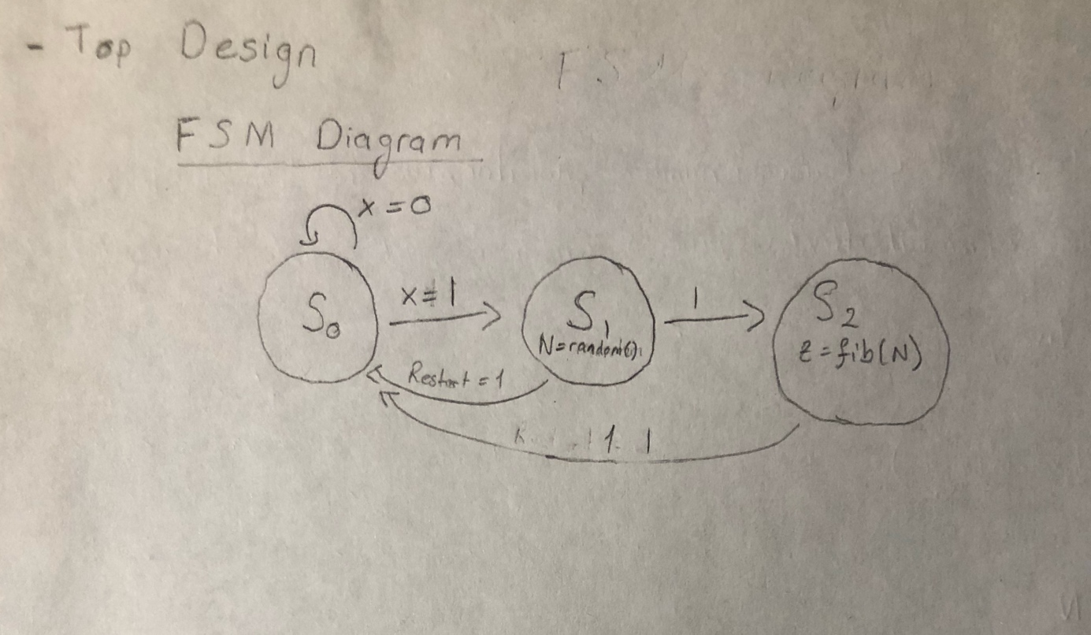

1. **Methods**

As we have mentioned in the introduction part, while implementing our Fibonacci numbers, we have used the iterative process. We created variables A, B and temp; therefore, we set the values of A and B to 0 and 1 respectively. In each iteration, we set the value of A to temp, then set the value of B to A. Then, we set the value of b to A+ temp. Which results in B, being the next Fibonacci number.

In the second part of the project we created a Pseudo Random Number Generator. In order to implement this, we used Linear Feedback Shift Register. Which used polynomial expansion to shift the registers.

Finally, we created a BCD method which converts our generated numbers to binary form. With the help of the BCD methods, we showed our results on the seven-segment.

1. **Experimental Result**

In LFSR, we have generated an 8-bit number, but we used only 4 bits in order to increase the randomness of the Pseudo Random Number Generator. We can at most calculate up to 19th Fibonacci number which is 6765. Each time we push the button, the input would become 1 and then we have calculated the next random Fibonacci number.

1. **Problems encountered, errors and warnings resolved**

When we tried to change our BCD method, we have encountered number not in range error. Therefore, we solved it by changing the range of the outputs.

1. **Conclusion**

We divided our project to three parts and worked on every part separately. First of all, we designed and implemented the random number generator. Therefore, we have implemented a function that takes the integer n as our input and returns the nth Fibonacci number. Then, we have implemented the

seven- segment display located on the FPGA board. For our project LFSR method is the easiest way to generate a pseudo random number. In order to implement the LFSR method we have only needed to use shift registers and it was quite straightforward on a FPGA board.

**References**

1)

Synth and Stompbox DIY,

“Practical LFSR Random Number Generators.”

electricdruid.net/practical-lfsr-random-number-generators/.

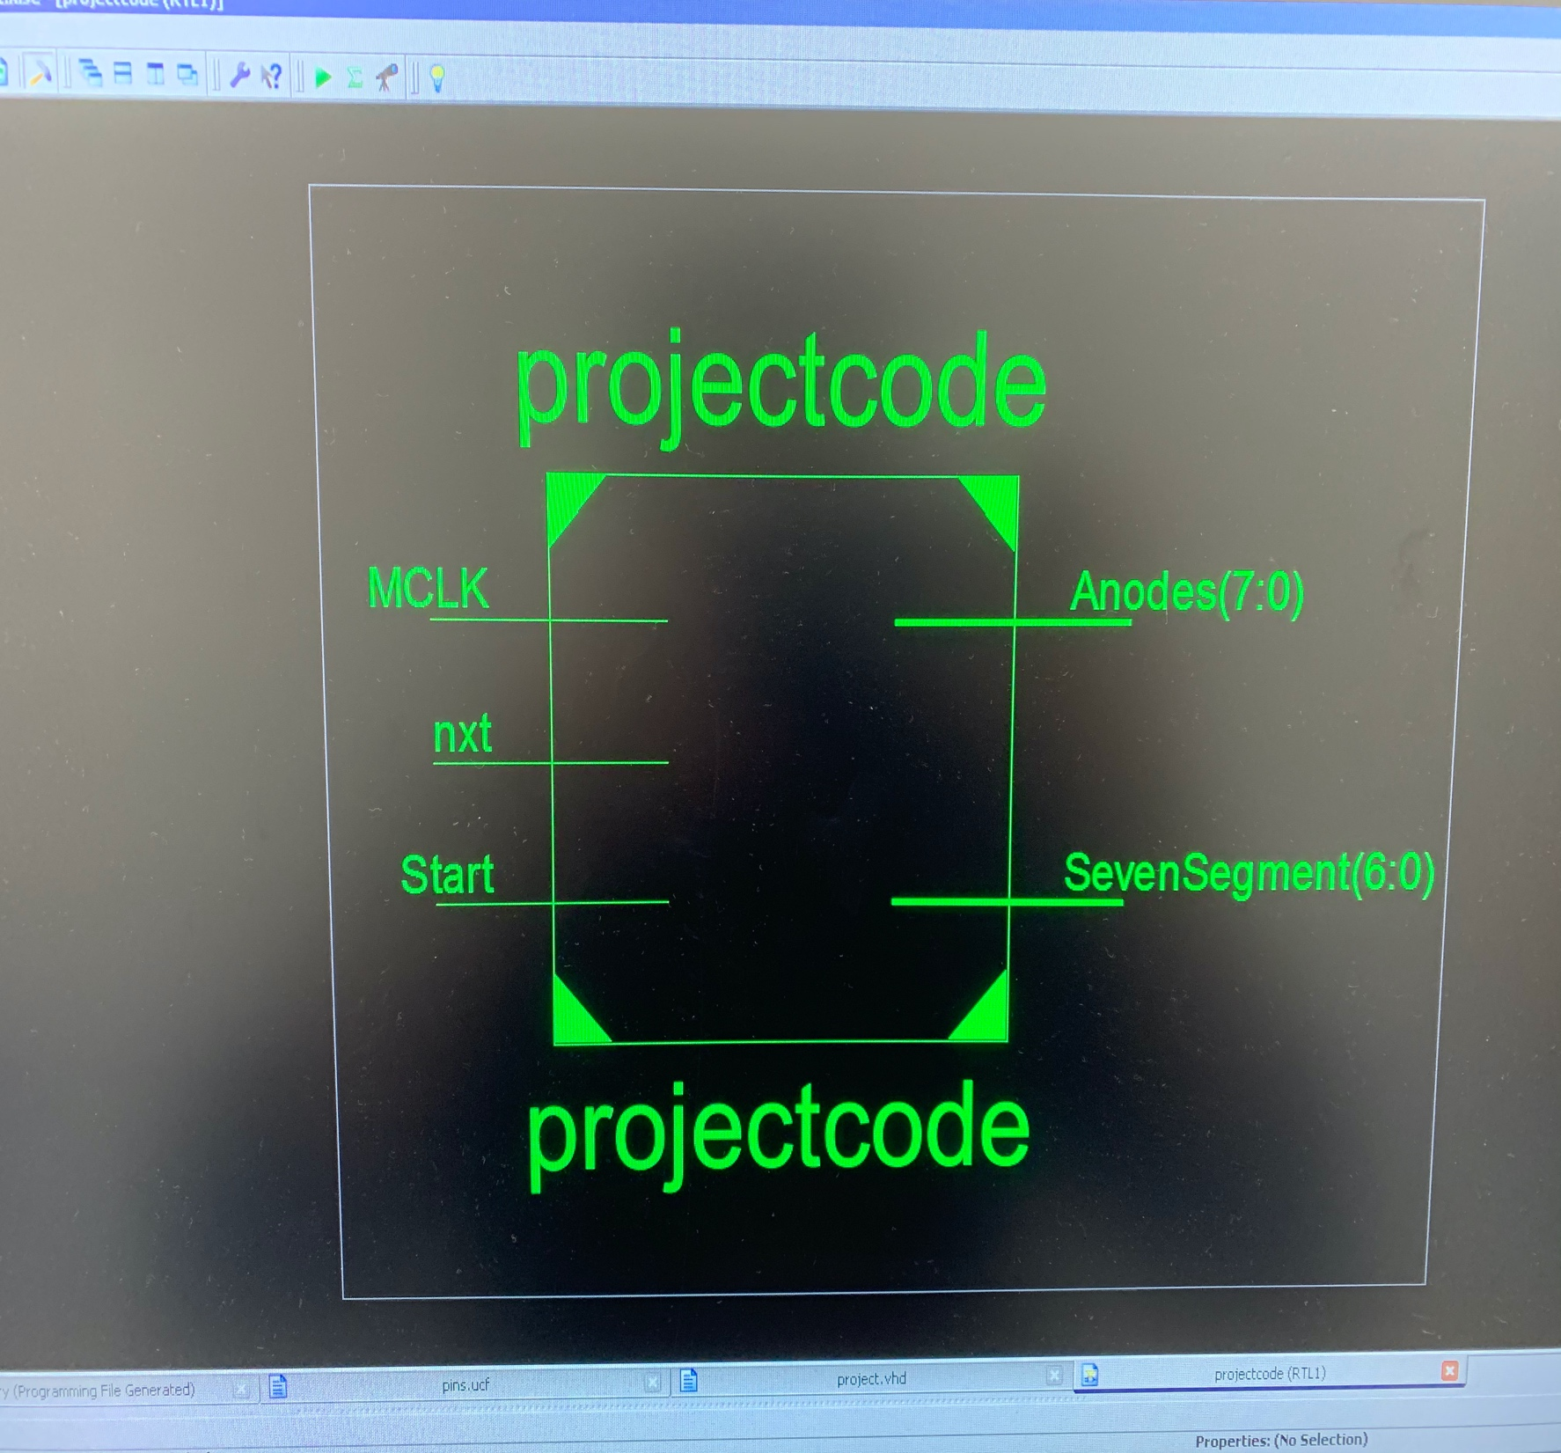

**Appendix 1. Lab source code**

----------------------------------------------------------------------------------  
-- Company:  
-- Engineer:  
--  
-- Create Date:    16:23:56 11/25/2019  
-- Design Name:  
-- Module Name:    projectcode - Behavioral  
-- Project Name:  
-- Target Devices:  
-- Tool versions:  
-- Description:  
--  
-- Dependencies:  
--  
-- Revision:  
-- Revision 0.01 - File Created  
-- Additional Comments:  
--  
----------------------------------------------------------------------------------  
library IEEE;  
use IEEE.STD_LOGIC_1164.ALL;  
use IEEE.STD_LOGIC_UNSIGNED.ALL;  
use IEEE.NUMERIC_STD.ALL;  
library UNISIM;  
use UNISIM.VComponents.all;  
  
-- Uncomment the following library declaration if using  
-- arithmetic functions with Signed or Unsigned values  
--use IEEE.NUMERIC_STD.ALL;  
  
-- Uncomment the following library declaration if instantiating  
-- any Xilinx primitives in this code.  
--library UNISIM;  
--use UNISIM.VComponents.all;  
  
entity projectcode is  
Generic (N : INTEGER:=50*10**6; M: INTEGER:=65536);  
Port ( MCLK : in STD_LOGIC;  
SevenSegment : out STD_LOGIC_VECTOR (6 downto 0);  
Anodes : out STD_LOGIC_VECTOR (7 downto 0);  
nxt : in STD_LOGIC;  
Start : in STD_LOGIC);  
end projectcode;  
  
architecture Behavioral of projectcode is  
  
signal CLK_DIV : STD_LOGIC;  
signal Out1: STD_LOGIC_VECTOR (3 downto 0);  
signal Out2: STD_LOGIC_VECTOR (3 downto 0);  
signal Out3: STD_LOGIC_VECTOR (3 downto 0);  
signal Out4: STD_LOGIC_VECTOR (3 downto 0);  
  
function to_bcd ( bin : std_logic_vector(13 downto 0) ) return std_logic_vector is  
variable i : integer:=0;  
variable bcd : std_logic_vector(15 downto 0) := (others => '0');  
variable bint : std_logic_vector(13 downto 0) := bin;  
begin  
  
for i in 0 to 13 loop  
bcd(15 downto 1) := bcd(14 downto 0);  
bcd(0) := bint(13);  
bint(13 downto 1) := bint(12 downto 0);  
bint(0) :='0';  
  
if(i < 13 and bcd(3 downto 0) > "0100") then  
bcd(3 downto 0) := bcd(3 downto 0) + "0011";  
end if;  
if(i < 13 and bcd(7 downto 4) > "0100") then  
bcd(7 downto 4) := bcd(7 downto 4) + "0011";  
end if;  
if(i < 13 and bcd(11 downto 8) > "0100") then  
bcd(11 downto 8) := bcd(11 downto 8) + "0011";  
end if;  
if(i < 13 and bcd(15 downto 12) > "0100") then  
bcd(15 downto 12) := bcd(15 downto 12) + "0011";  
end if;  
  
end loop;  
return bcd;  
end function;  
  
function fib(n : INTEGER) return integer is  
  
variable a : INTEGER:=0;  
variable b : INTEGER:=1;  
variable temp : INTEGER:=0;  
  
begin  
  
for i in 0  to 18 loop  
temp := a;  
a := b;  
b := a + temp;  
exit when i >= n;  
  
end loop;  
return b;  
end fib;  
  
signal fib_bcd :  std_logic_vector(15 downto 0);  
signal temp :  std_logic_vector(13 downto 0);  
signal Qt : std_logic_vector(7 downto 0) := x"01";  
signal Q : std_logic_vector(4 downto 0);  
  
  
begin  
  
process(MCLK)  
variable Counter : INTEGER range 0 to N;  
begin    
        if rising_edge(MCLK) then  
            Counter := Counter + 1;  
             if (Counter = N/15-1) then  
                    Counter := 0;  
                    CLK_DIV <= not CLK_DIV;              
             end if;  
        end if;  
end process;  
  
process(CLK_DIV)  
variable n : INTEGER;  
variable x1 : INTEGER;  
variable tmp : std_logic;  
  
begin  
  
tmp := '0';  
  
if rising_edge(CLK_DIV) then  
if start='1' then  
Qt <= x"01";  
else  
tmp := Qt(4) xor Qt(3) xor Qt(2) xor Qt(0);  
if nxt = '1' then  
Qt <= tmp & Qt(7 downto 1);  
Q <= Qt(7 downto 3);  
end if;  
end if;  
end if;  
  
if rising_edge(CLK_DIV) then  
n := to_integer(unsigned(Q));  
x1 := fib(n);  
temp <= std_logic_vector(to_unsigned(x1, temp'length));  
  
fib_bcd <= to_bcd(temp);  
  
Out1 <= fib_bcd(15 downto 12);  
Out2 <= fib_bcd(11 downto 8);  
Out3 <= fib_bcd(7 downto 4);  
Out4 <= fib_bcd(3 downto 0);  
end if;  
  
end process;  
  
process(MCLK)  
  
    variable Counter : INTEGER range 0 to M;  
  
    begin        
  
        if(rising_edge(MCLK)) then  
  
            Counter :=Counter+1;  
  
            if (Counter mod M = 0) then  
                if(Out4="0000") then  
                    Anodes <= "11111110";  
                    SevenSegment <= "0000001"; -- "0"  
                elsif (Out4="0001") then  
                    Anodes <= "11111110";  
                    SevenSegment <= "1001111"; -- "1"  
                elsif (Out4="0010") then  
                    Anodes <= "11111110";  
                    SevenSegment <= "0010010"; -- "2"  
                elsif (Out4="0011") then  
                    Anodes <= "11111110";  
                    SevenSegment <= "0000110"; -- "3"  
                elsif (Out4="0100") then  
                    Anodes <= "11111110";  
                    SevenSegment <= "1001100"; -- "4"  
                elsif (Out4="0101") then  
                    Anodes <= "11111110";  
                    SevenSegment <= "0100100"; -- "5"  
                elsif (Out4="0110") then  
                    Anodes <= "11111110";  
                    SevenSegment <= "0100000"; -- "6"  
                elsif (Out4="0111") then  
                    Anodes <= "11111110";  
                    SevenSegment <= "0001111"; -- "7"  
                elsif (Out4="1000") then  
                    Anodes <= "11111110";  
                    SevenSegment <= "0000000"; -- "8"  
                elsif (Out4="1001") then  
                    Anodes <= "11111110";  
                    SevenSegment <= "0000100"; -- "9"  
                end if;  
            elsif (Counter mod M = 1*M/8) then  
                if(Out3="0000") then  
                    Anodes <= "11111101";  
                    SevenSegment <= "0000001"; -- "0"  
                elsif (Out3="0001") then  
                    Anodes <= "11111101";  
                    SevenSegment <= "1001111"; -- "1"  
                elsif (Out3="0010") then  
                    Anodes <= "11111101";  
                    SevenSegment <= "0010010"; -- "2"  
                elsif (Out3="0011") then  
                    Anodes <= "11111101";  
                    SevenSegment <= "0000110"; -- "3"  
                elsif (Out3="0100") then  
                    Anodes <= "11111101";  
                    SevenSegment <= "1001100"; -- "4"  
                elsif (Out3="0101") then  
                    Anodes <= "11111101";  
                    SevenSegment <= "0100100"; -- "5"  
                elsif (Out3="0110") then  
                    Anodes <= "11111101";  
                    SevenSegment <= "0100000"; -- "6"  
                elsif (Out3="0111") then  
                    Anodes <= "11111101";  
                    SevenSegment <= "0001111"; -- "7"  
                elsif (Out3="1000") then  
                    Anodes <= "11111101";  
                    SevenSegment <= "0000000"; -- "8"  
                elsif (Out3="1001") then  
                    Anodes <= "11111101";  
                    SevenSegment <= "0000100"; -- "9"  
                end if;  
            elsif (Counter mod M = 2*M/8) then  
                if(Out2="0000") then  
                    Anodes <= "11111011";  
                    SevenSegment <= "0000001"; -- "0"  
                elsif (Out2="0001") then  
                    Anodes <= "11111011";  
                    SevenSegment <= "1001111"; -- "1"  
                elsif (Out2="0010") then  
                    Anodes <= "11111011";  
                    SevenSegment <= "0010010"; -- "2"  
                elsif (Out2="0011") then  
                    Anodes <= "11111011";  
                    SevenSegment <= "0000110"; -- "3"  
                elsif (Out2="0100") then  
                    Anodes <= "11111011";  
                    SevenSegment <= "1001100"; -- "4"  
                elsif (Out2="0101") then  
                    Anodes <= "11111011";  
                    SevenSegment <= "0100100"; -- "5"  
                elsif (Out2="0110") then  
                    Anodes <= "11111011";  
                    SevenSegment <= "0100000"; -- "6"  
                elsif (Out2="0111") then  
                    Anodes <= "11111011";  
                    SevenSegment <= "0001111"; -- "7"  
                elsif (Out2="1000") then  
                    Anodes <= "11111011";  
                    SevenSegment <= "0000000"; -- "8"  
elsif (Out2="1001") then  
Anodes <= "11111011";  
SevenSegment <= "0000100"; -- "9"  
                end if;  
  
elsif (Counter mod M = 3*M/8) then  
                if(Out1="0000") then  
                    Anodes <= "11110111";  
                    SevenSegment <= "0000001"; -- "0"  
                elsif (Out1="0001") then  
                    Anodes <= "11110111";  
                    SevenSegment <= "1001111"; -- "1"  
                elsif (Out1="0010") then  
                    Anodes <= "11110111";  
                    SevenSegment <= "0010010"; -- "2"  
                elsif (Out1="0011") then  
                    Anodes <= "11110111";  
                    SevenSegment <= "0000110"; -- "3"  
                elsif (Out1="0100") then  
                    Anodes <= "11110111";  
                    SevenSegment <= "1001100"; -- "4"  
                elsif (Out1="0101") then  
                    Anodes <= "11110111";  
                    SevenSegment <= "0100100"; -- "5"  
                elsif (Out1="0110") then  
                    Anodes <= "11110111";  
                    SevenSegment <= "0100000"; -- "6"  
                elsif (Out1="0111") then  
                    Anodes <= "11110111";  
                    SevenSegment <= "0001111"; -- "7"  
                elsif (Out1="1000") then  
                    Anodes <= "11110111";  
                    SevenSegment <= "0000000"; -- "8"  
                elsif (Out1="1001") then  
                    Anodes <= "11110111";  
                    SevenSegment <= "0000100"; -- "9"  
                end if;  
end if;  
        end if;  
    end process;  
end Behavioral;

------------------------------------

**PINs**

NET "MCLK"  LOC = "P40";      
NET "nxt" LOC = "P32";  
    
   
NET "Anodes<0>" LOC = "P50" ;  
NET "Anodes<1>" LOC = "P49" ;  
NET "Anodes<2>" LOC = "P52" ;  
NET "Anodes<3>" LOC = "P56" ;  
NET "Anodes<4>" LOC = "P59" ;  
NET "Anodes<5>" LOC = "P57" ;  
NET "Anodes<6>" LOC = "P60" ;  
NET "Anodes<7>" LOC = "P61" ;  
   
NET "SevenSegment<0>" LOC = "P64" ;  
NET "SevenSegment<1>" LOC = "P98" ;  
NET "SevenSegment<2>" LOC = "P73" ;  
NET "SevenSegment<3>" LOC = "P72" ;  
NET "SevenSegment<4>" LOC = "P65" ;  
NET "SevenSegment<5>" LOC = "P62" ;  
NET "SevenSegment<6>" LOC = "P71" ;

**Appendix 3. FPGA Board photos showing working code**

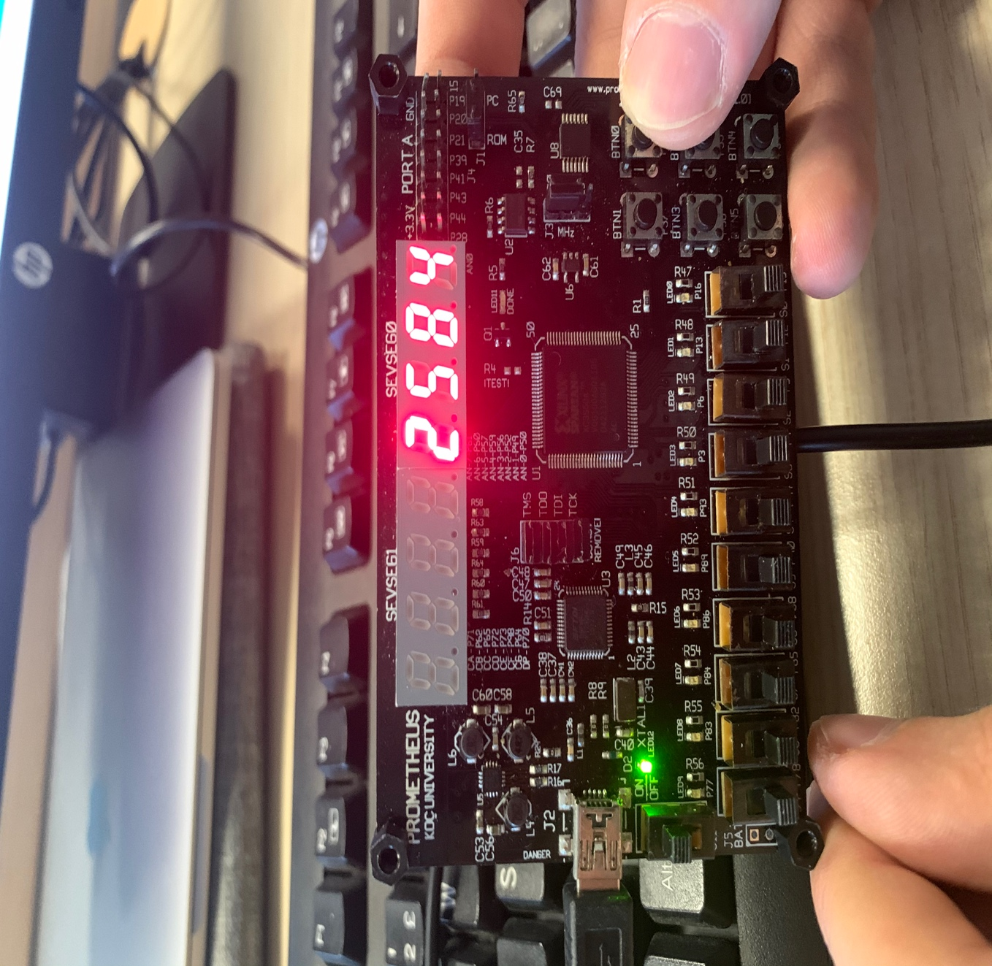

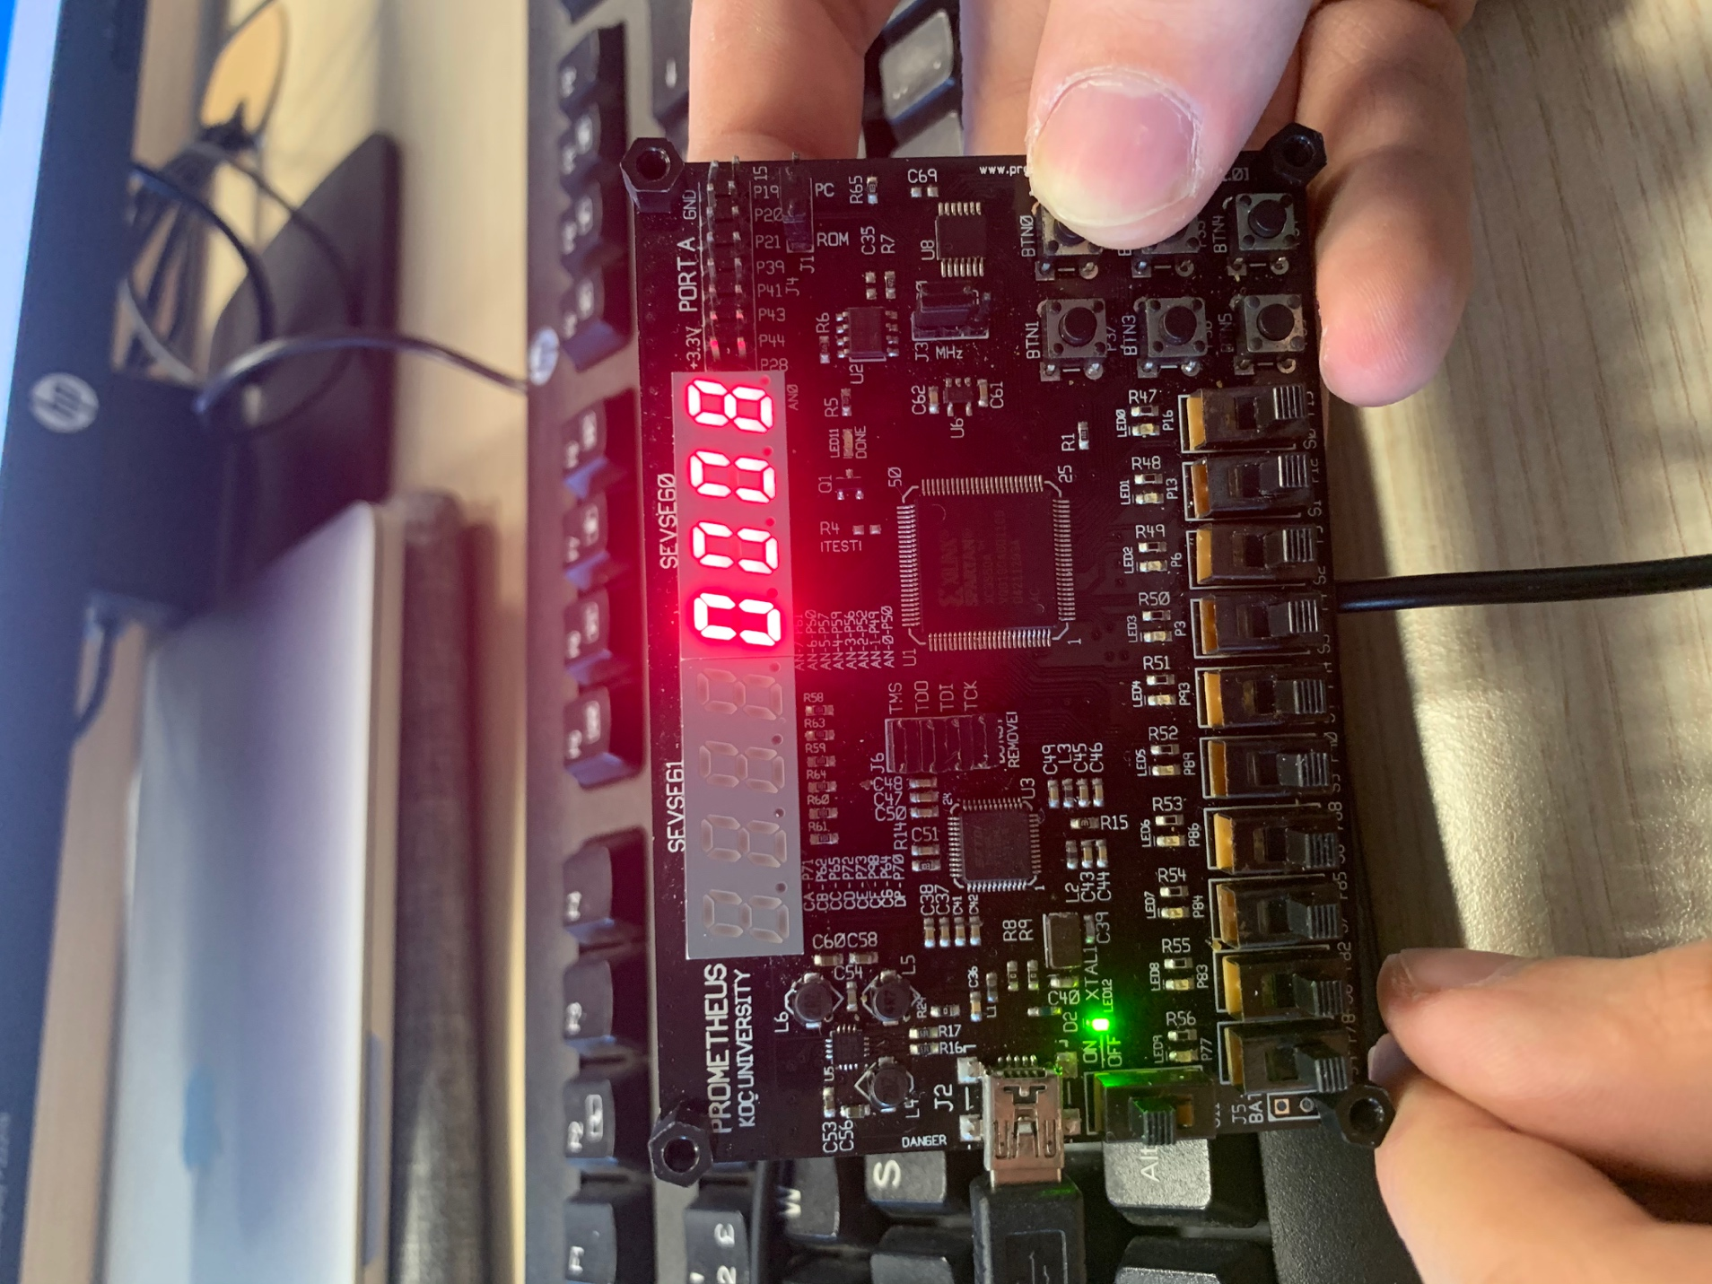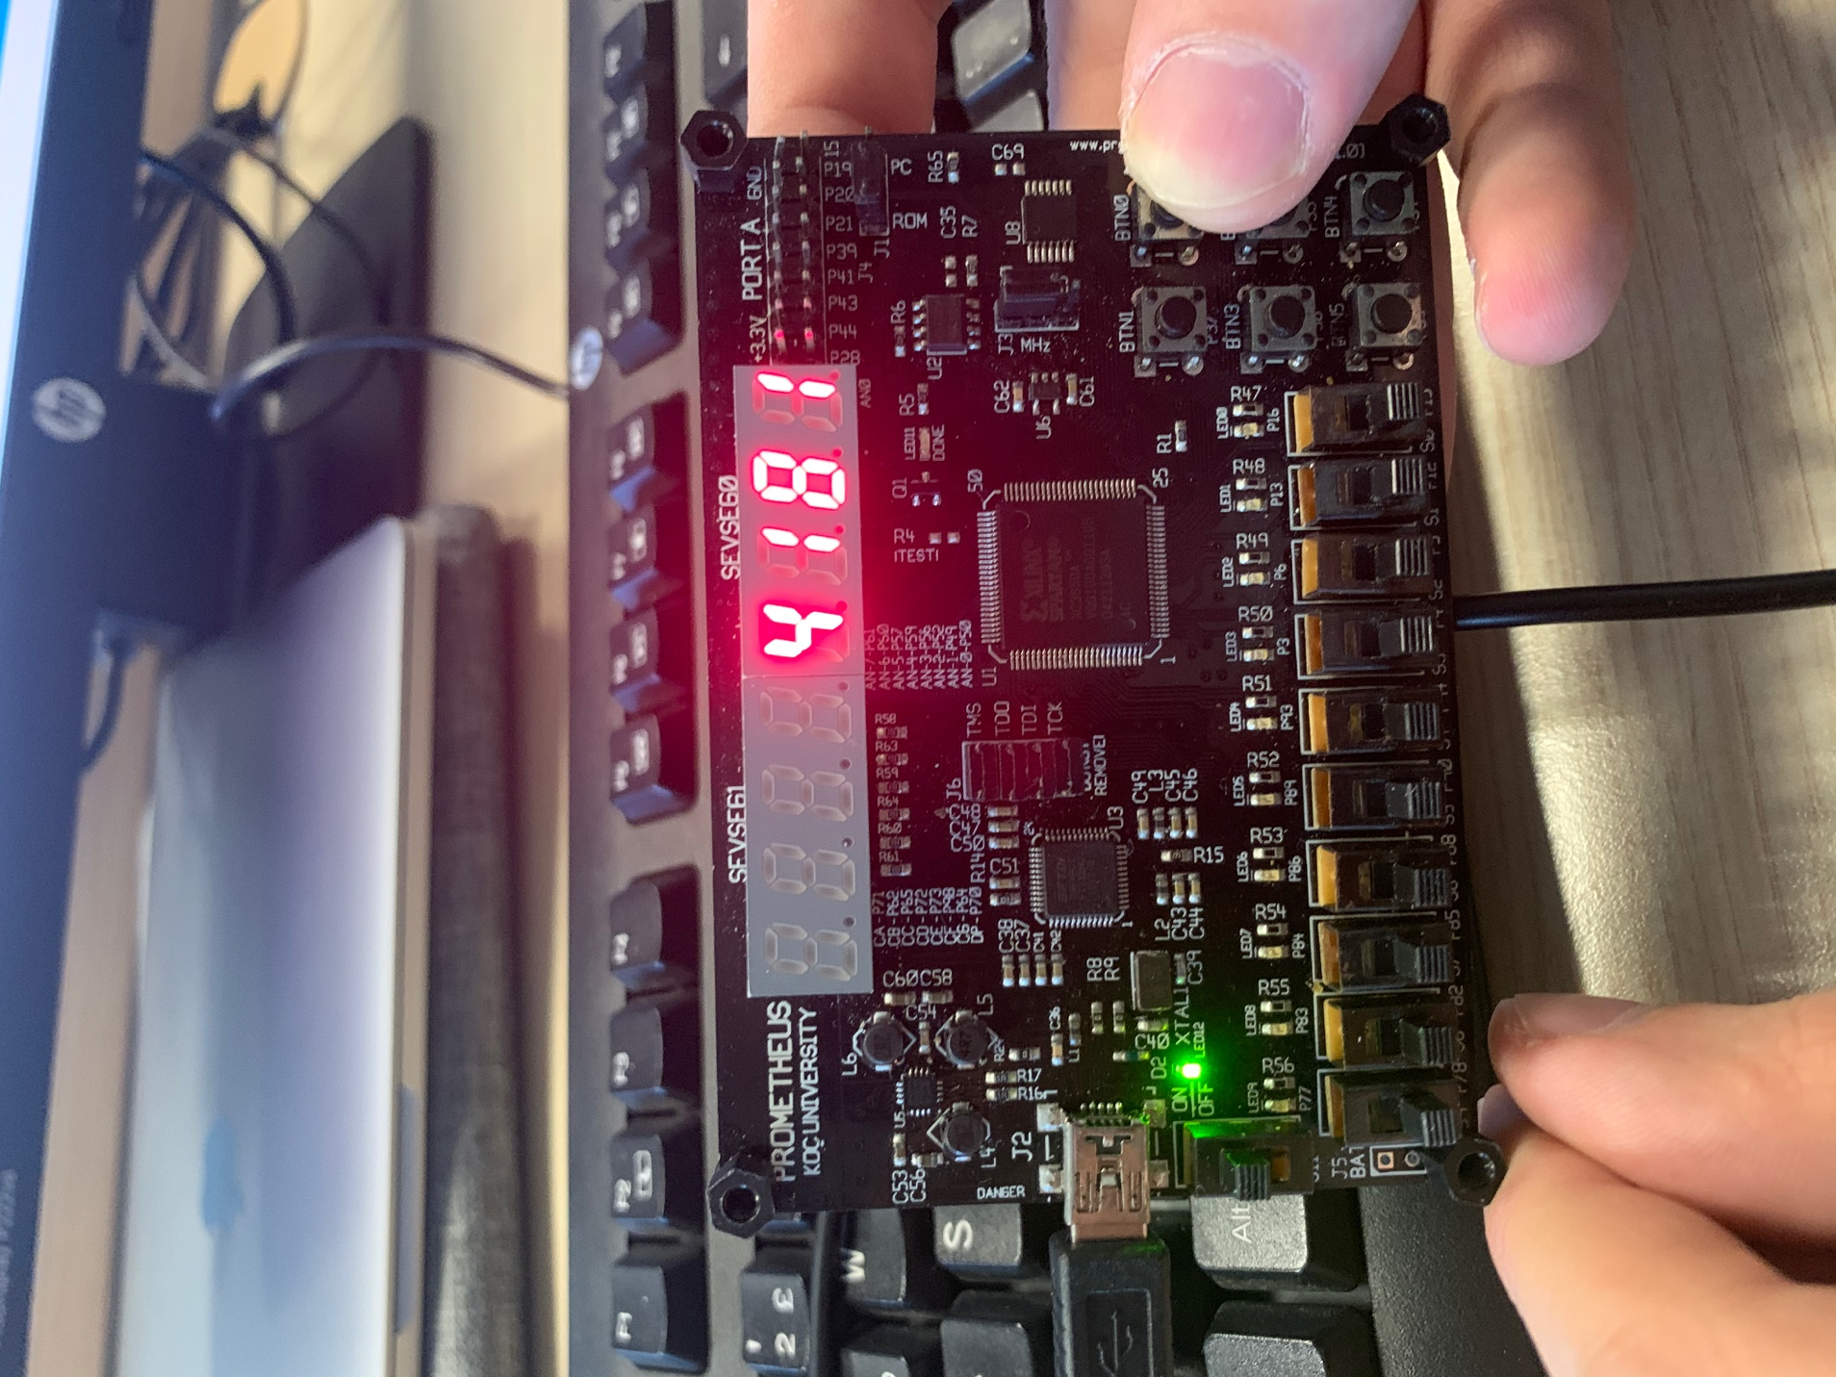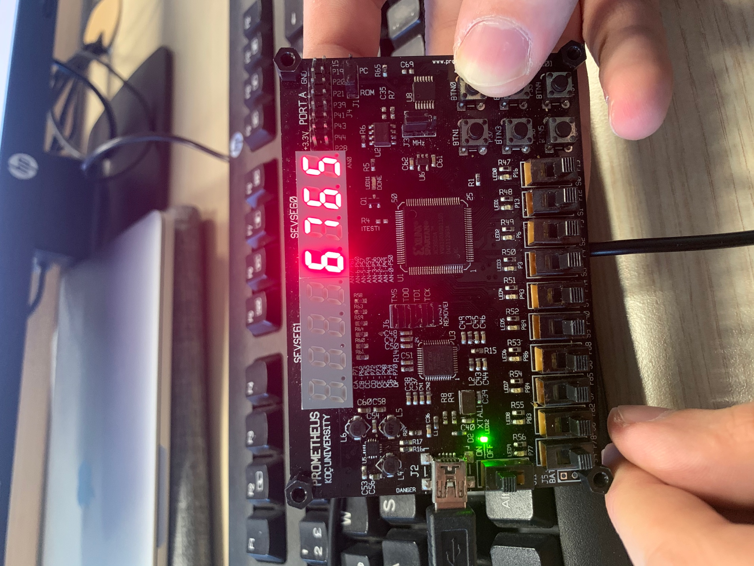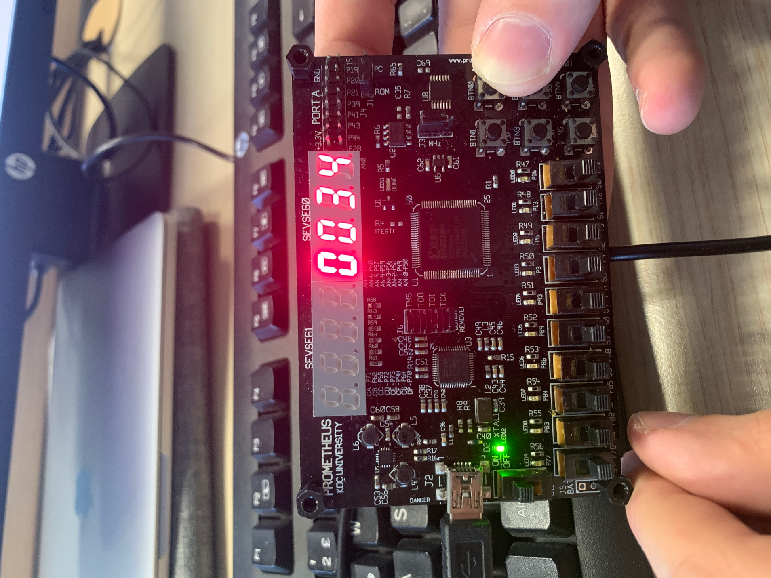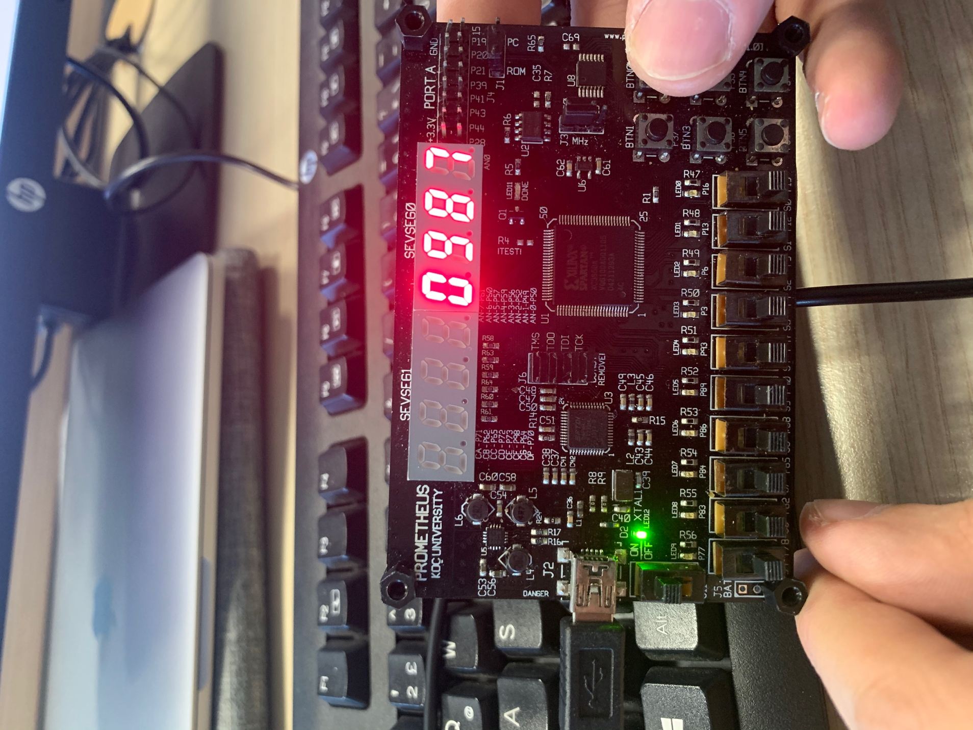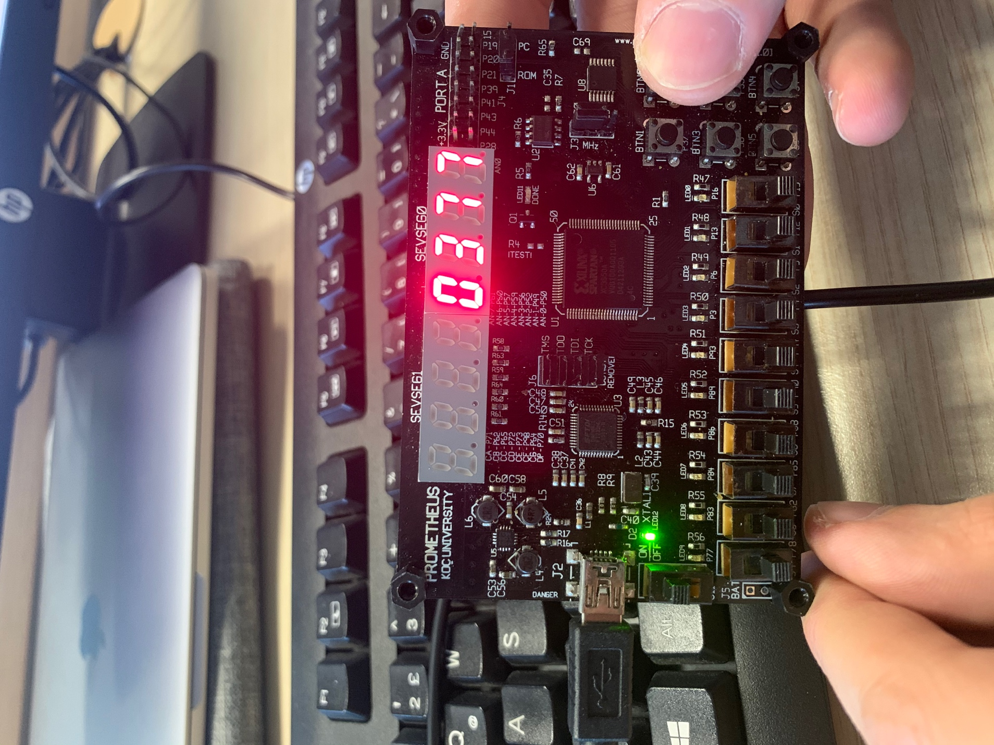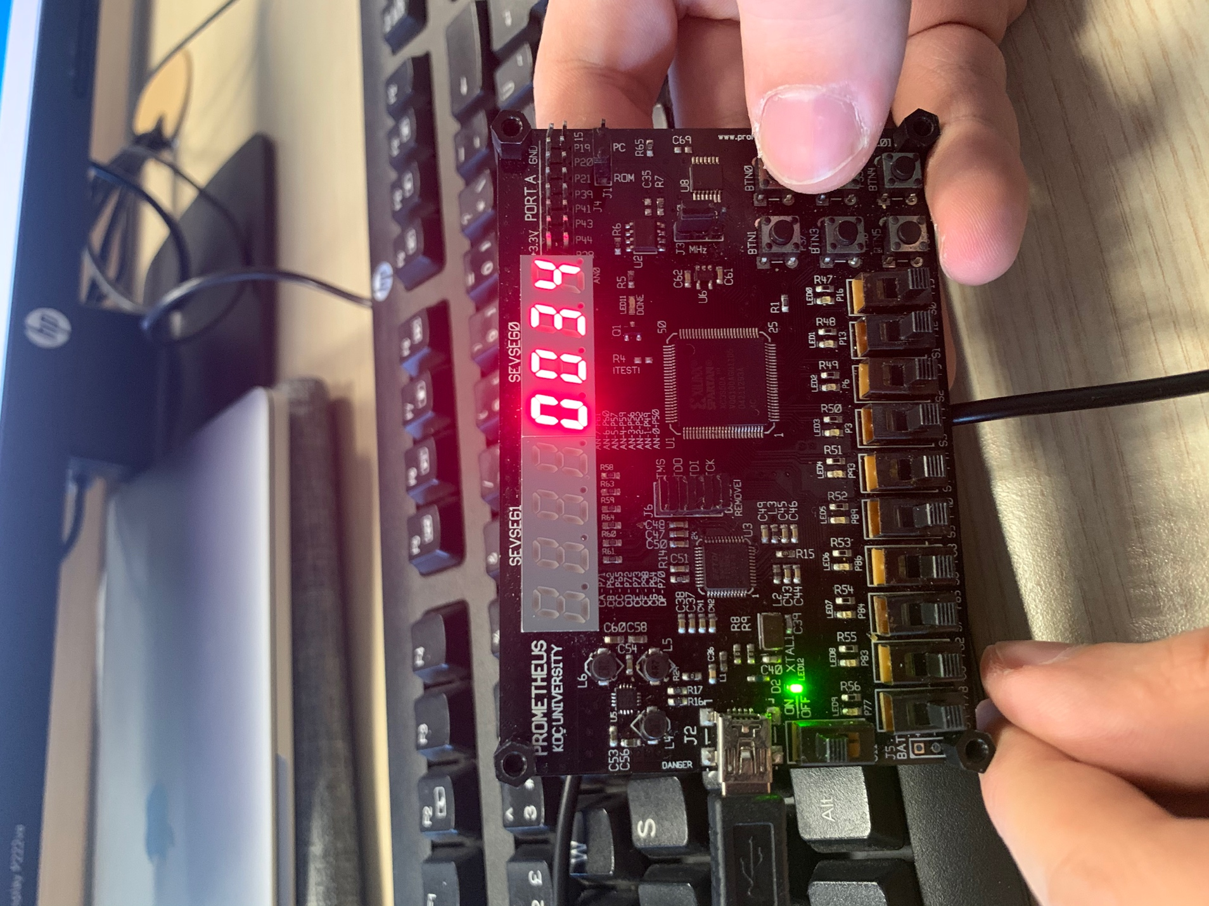

**Appendix 4.**

